No | Task | Status
1. | I can't change the certificate, although I was able to last time. It seems something has  moved. I have set the sheet size in cm and also in pixels and it does not allow me to  upload it. | DONE  Sorry I forget to disable image size resolution checker
2. | A link When I click here, the next page to appear should only show the data in the  table. | DONE  Now its only show table  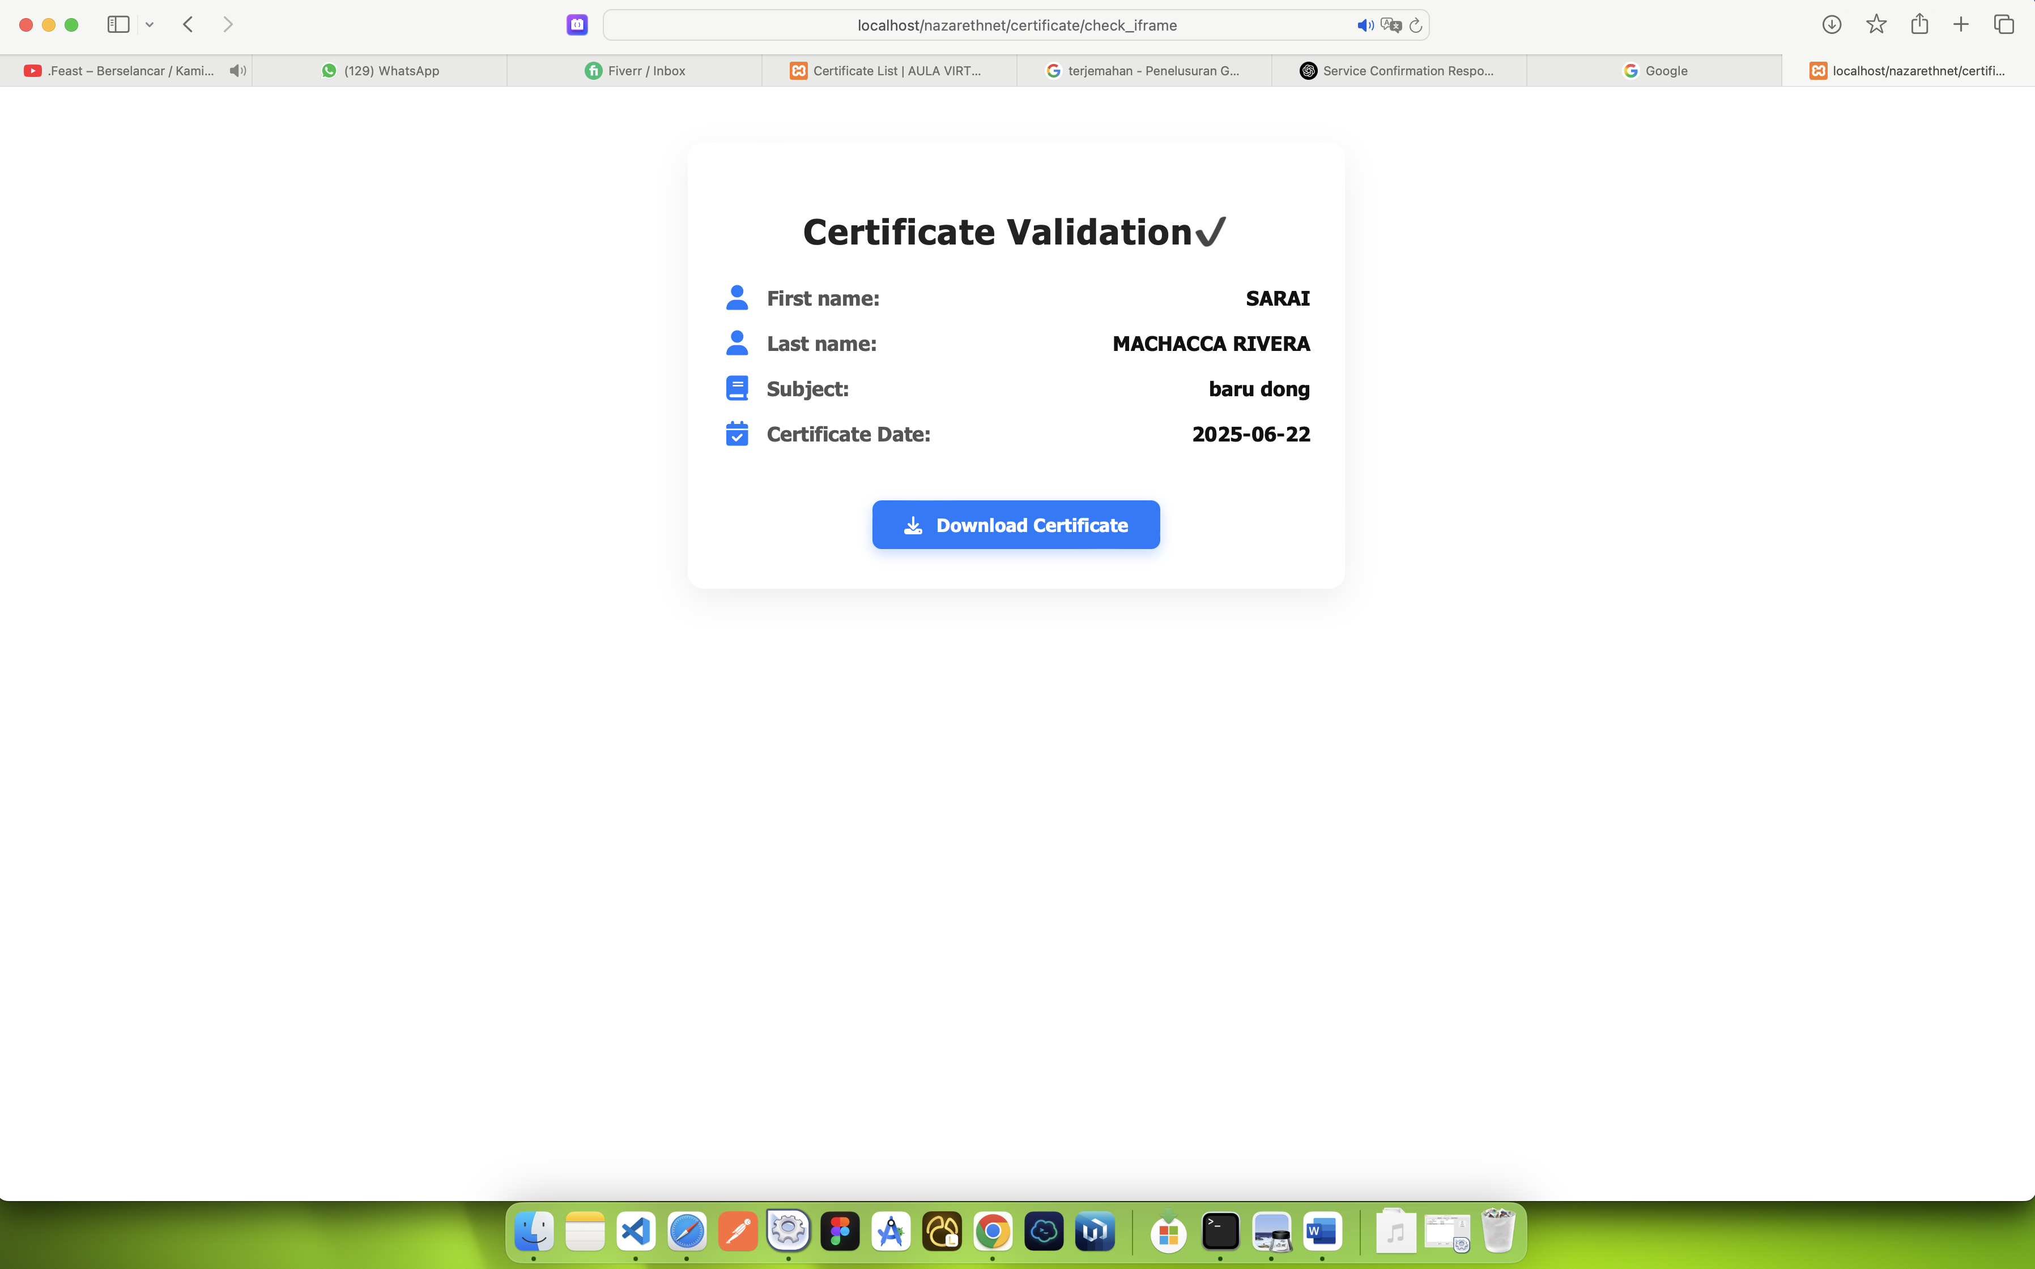
3. | You have the option to download all course information without prior selection.  Section (missing)  Course (missing)  Students (Check)  Exam (missing) | DONE  You can export with this condition  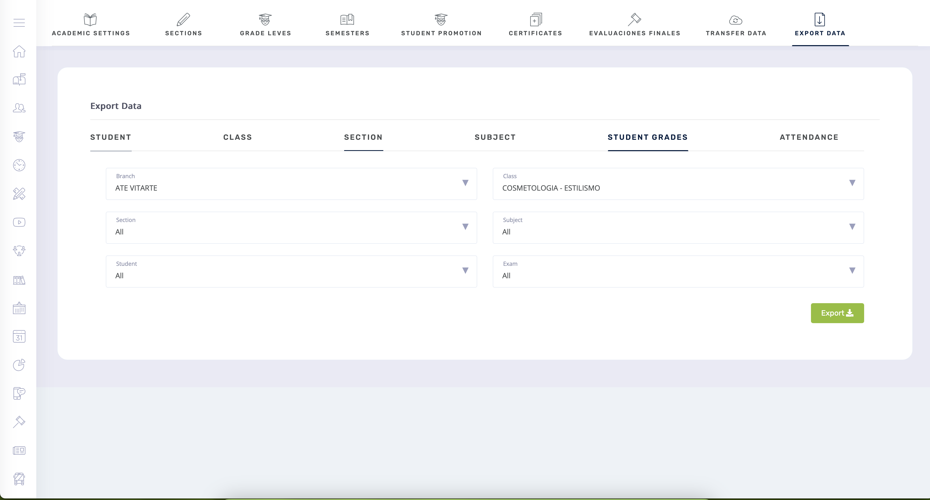
4. | You have the option to download all student attendance records without prior selection.  Section (missing)  Course (missing)  Students (Check)  Exam (missing) | Done  You can export with this condition  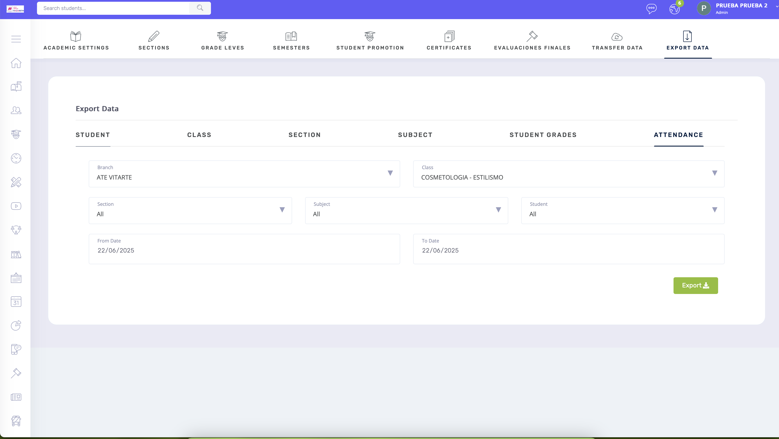
5. | 4.1. If the course already exists, it already has activities.  ROOM A: COURSE A  ROOM B: COURSE A  Both classrooms already exist and already have activities, assignments, and tests created.  Example: I have a student, Sarai, who is in ROOM A, and I'm going to transfer her to ROOM B.  She must transfer without the activities because that room already has the activities created.  I understand that it's not possible to transfer with the grades; honestly, that would be ideal.  Actually, I don't think it's very useful if, when we duplicate the course, all the information is  duplicated, and I can manually activate it in room B and enter the grades manually.  There's no way to transfer her with the grades already prepared. If you take the time, it  doesn't matter, I'd work with what we have now for the time being.  The student remains in room A, even though she has already transferred to room B. | DONE  I have changed the logic so you can transfer student grades without any duplicate exams or double mark_activity on the target. This feature works by searching for the same exam name and mark activity name, then the student will be transferred from the source along with his/her grades.  For example:  I will transfer ruth

Point 4 example new working:
i will transfer student RUTH Mery (From corte de caballero L-MI-VI10A 1PM)
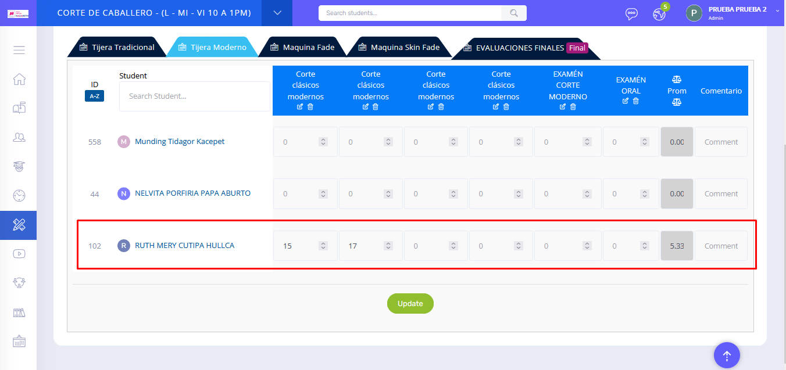

With target CORTE DE CABALLERO - Duplicate 5328 COSMETOLOGIA - ESTILISMO "L - MI - VI 10 A 1PM" Here there is no student with the name Ruth Mery

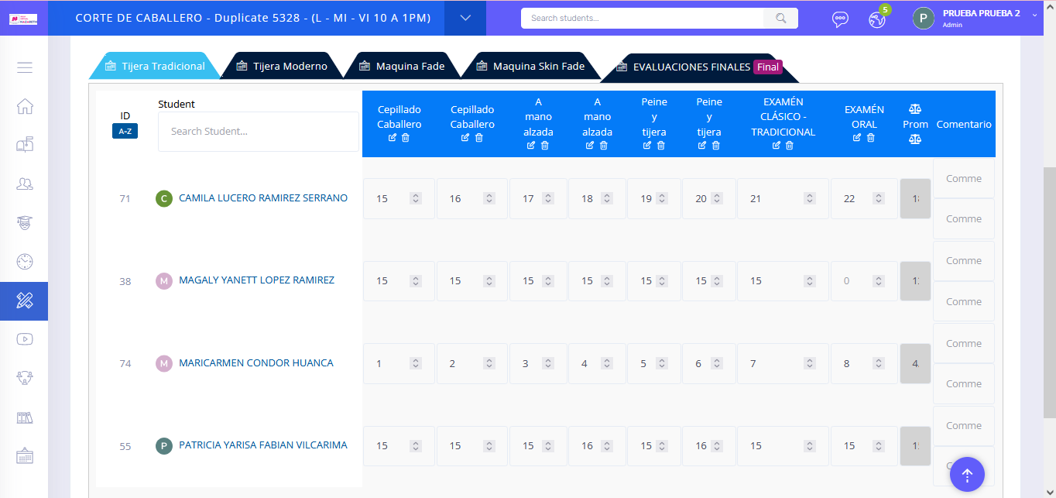
because the L-MI-VI10A 1PM Caballero Corte has the same exam name, and the value transfer activity makes it possible to do so
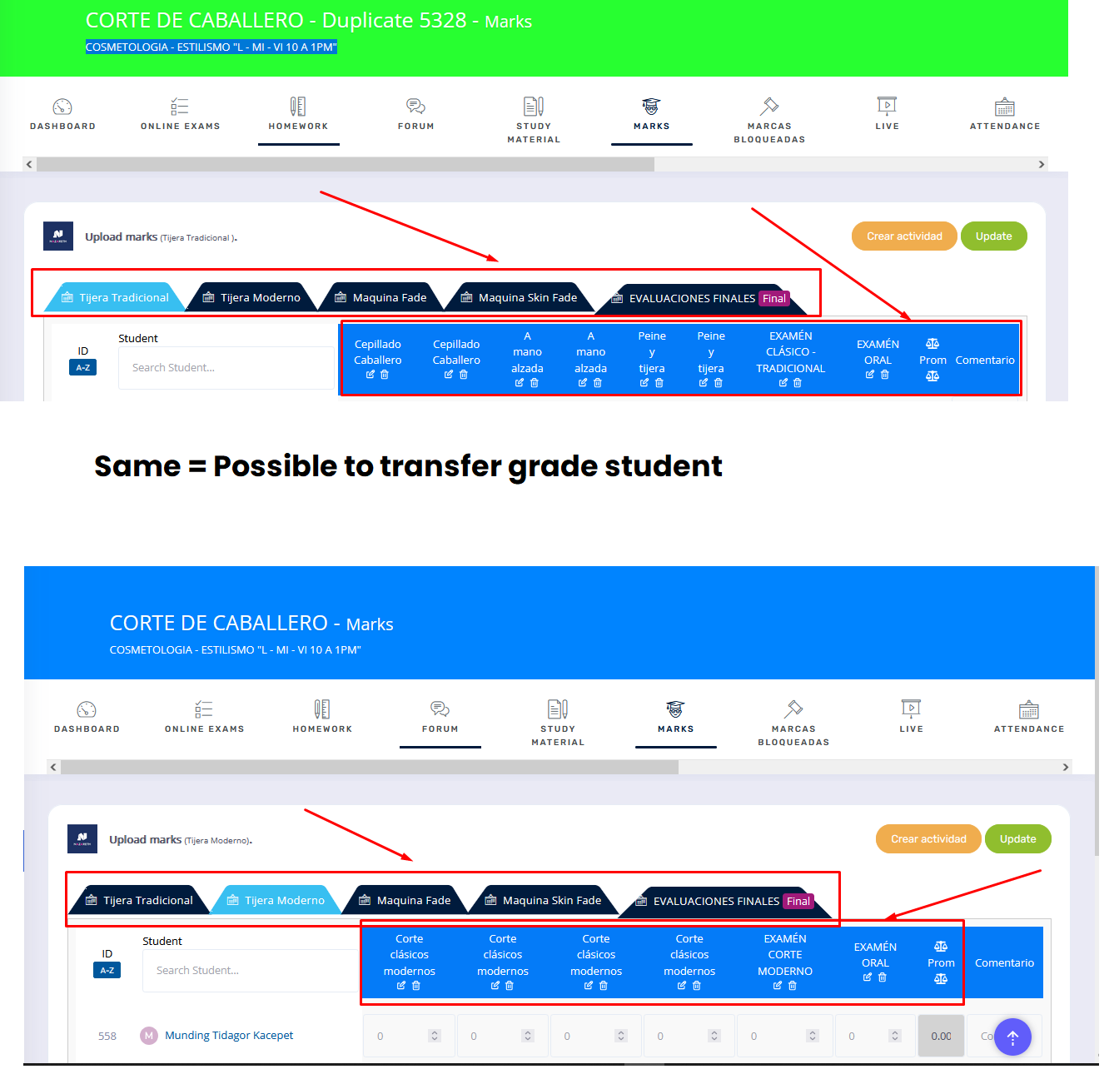

After Success transfer student with name RUTH MERY its removed from source
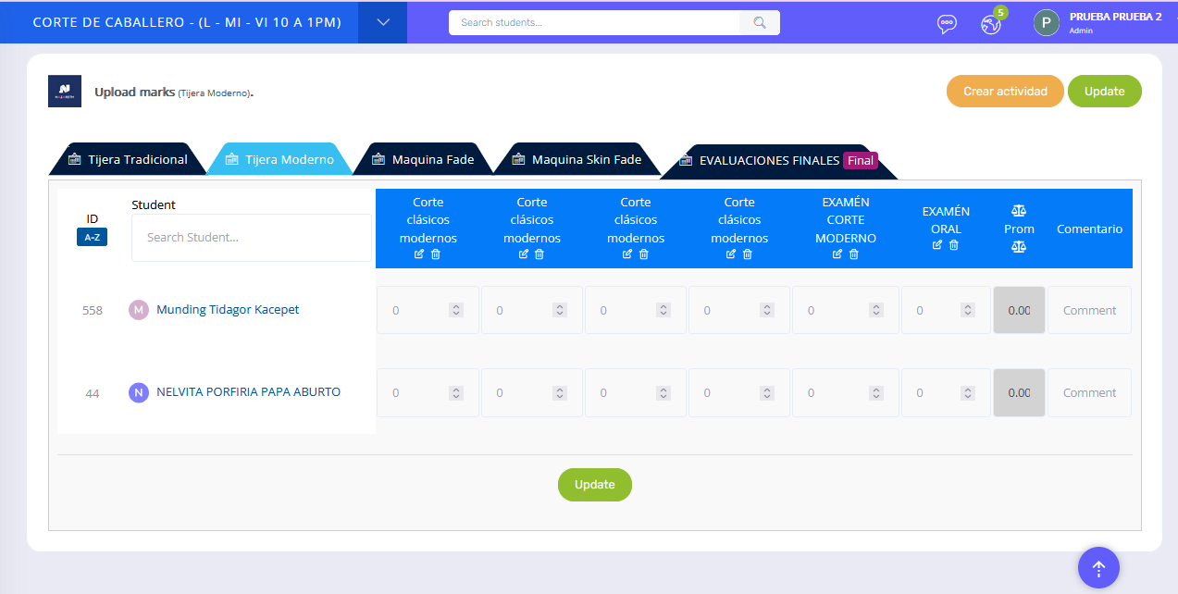
And appears in Target with same grade value
